CrowSoft MySQL Script & Admin User

Contents

Log into MySQL Database Remotely 1

Create Database Schema 3

Adding a admin user 4

Run SQL script 5

# Log into MySQL Database Remotely

You will need MySQL Workbench if you would like to access the MySQL database from you desktop / home pc. Here is the link (It’s open source): <https://dev.mysql.com/downloads/workbench/>

Open MySQL Workbench, and go to Database, Connect to Database

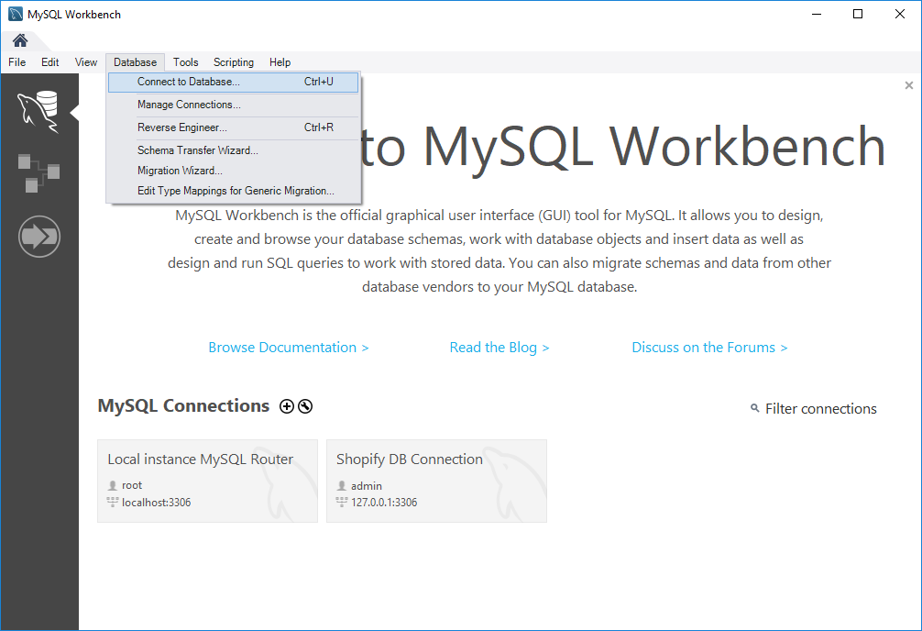

Click on Connection Method and select: Standard TCP/IP over SSH

Change the following settings

* SSH Hostname: 172.28.25.133:22
* SSH Username: devadmin
* SSH Password: refer to dev server password posted on Slack (You can store the password in Vault)
* MySQL Hostname: 172.28.25.133
* MySQL Server port: 3306
* Username: dbadmin
* Password: refer to dev server password posted on Slack (You can store the password in Vault)

Then click on OK

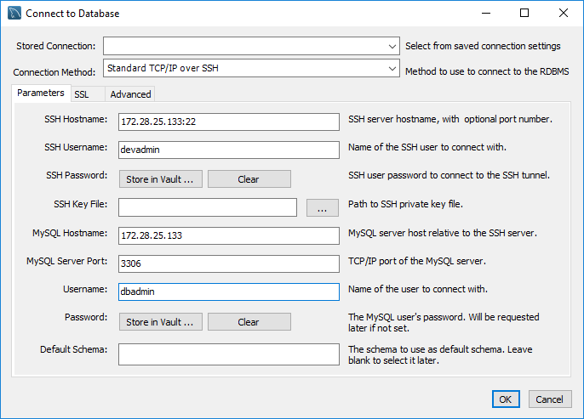

# Create Database Schema

Go to the Schemas tab, and right click, then click on Create Schema.

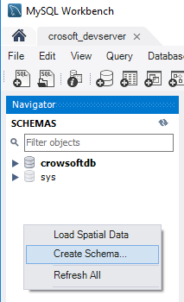

Type in database name in Name column and apply.

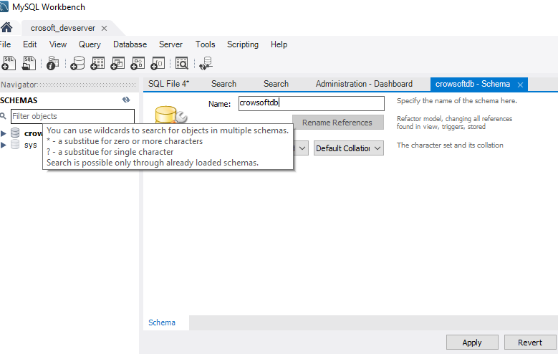

# Adding a admin user

Go to Server and click on Users and Privileges

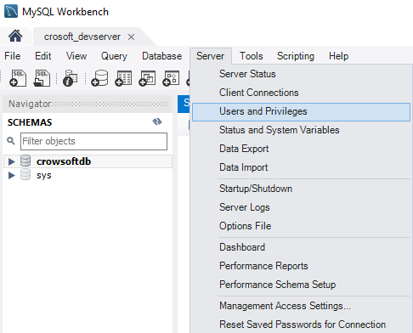

Click on Add Account, enter username and password.

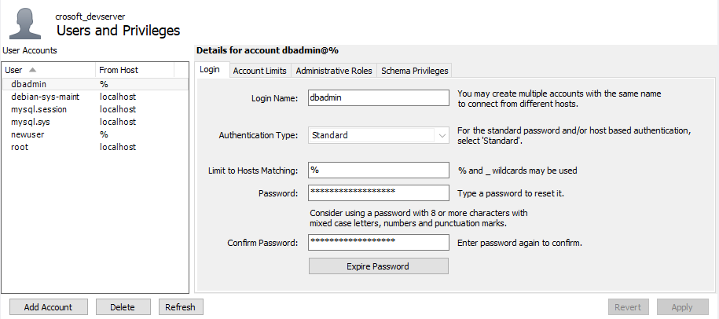

Click on Administrative Roles and all roles and all Global Privileges

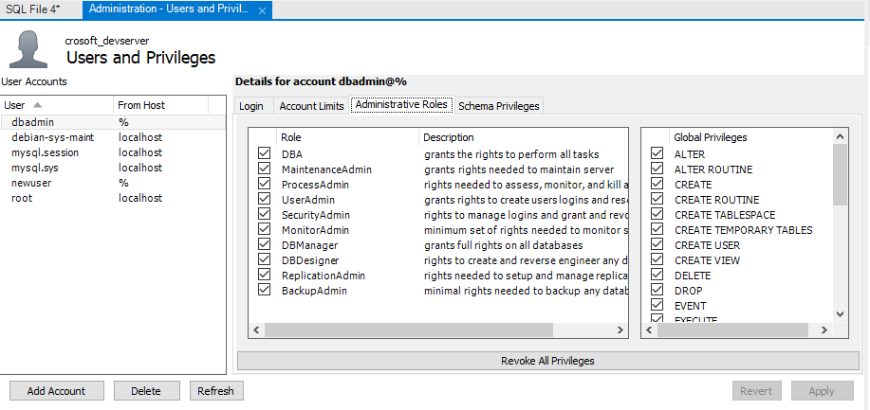

# Run SQL script

Click on Create a new SQL tab for executing queries Button.

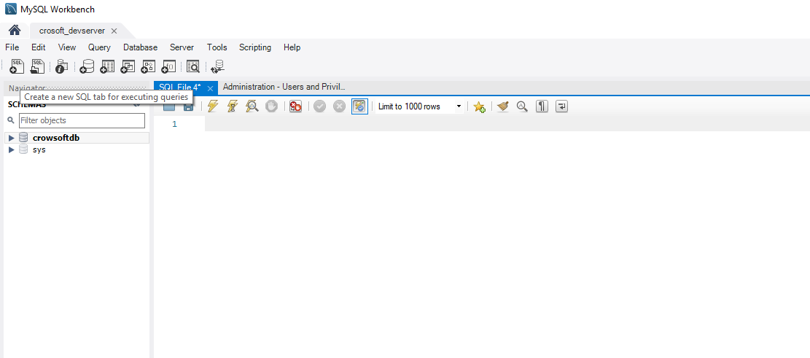

Copy and Paste SQL script (Find script in appendix) and click Execute Icon 

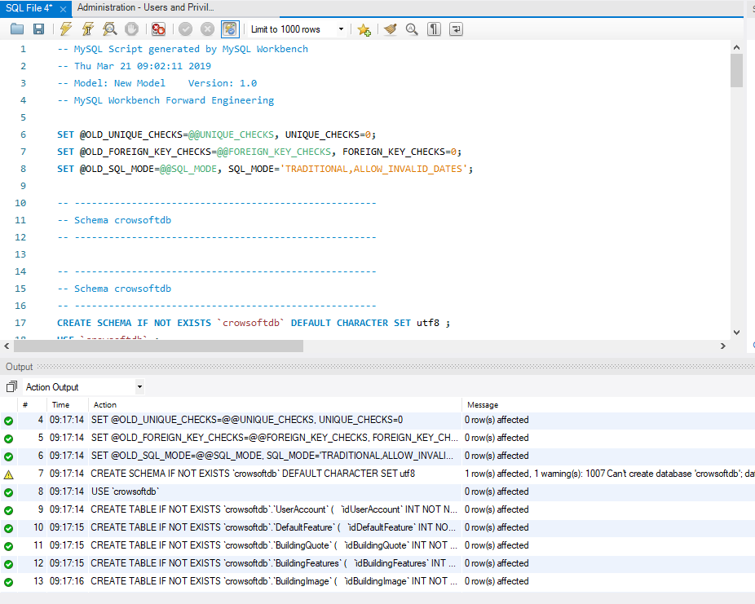

Right click on crowsoftdb and click Refresh All.

Open Tables and view tables.

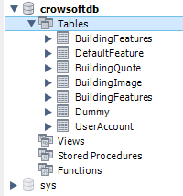

Appendix

-- MySQL Script generated by MySQL Workbench

-- Thu Mar 21 09:02:11 2019

-- Model: New Model Version: 1.0

-- MySQL Workbench Forward Engineering

SET @OLD_UNIQUE_CHECKS=@@UNIQUE_CHECKS, UNIQUE_CHECKS=0;

SET @OLD_FOREIGN_KEY_CHECKS=@@FOREIGN_KEY_CHECKS, FOREIGN_KEY_CHECKS=0;

SET @OLD_SQL_MODE=@@SQL_MODE, SQL_MODE='TRADITIONAL,ALLOW_INVALID_DATES';

-- -----------------------------------------------------

-- Schema crowsoftdb

-- -----------------------------------------------------

-- -----------------------------------------------------

-- Schema crowsoftdb

-- -----------------------------------------------------

CREATE SCHEMA IF NOT EXISTS `crowsoftdb` DEFAULT CHARACTER SET utf8 ;

USE `crowsoftdb` ;

-- -----------------------------------------------------

-- Table `crowsoftdb`.`UserAccount`

-- -----------------------------------------------------

CREATE TABLE IF NOT EXISTS `crowsoftdb`.`UserAccount` (

`idUserAccount` INT NOT NULL AUTO_INCREMENT,

`EmailAddress` VARCHAR(150) NOT NULL COMMENT 'User email address used as username as well. ',

`Password` VARCHAR(50) NOT NULL,

`FirstName` VARCHAR(60) NOT NULL,

`LastName` VARCHAR(60) NOT NULL,

`TelephoneNo` VARCHAR(45) NOT NULL,

`AddressLine` VARCHAR(150) NULL,

`County` VARCHAR(45) NULL,

`Country` VARCHAR(60) NULL,

`EirCode` VARCHAR(20) NULL,

`CompanyName` VARCHAR(45) NULL,

`TypeUser` VARCHAR(15) NOT NULL,

`DateCreated` DATETIME NOT NULL DEFAULT CURRENT_TIMESTAMP,

PRIMARY KEY (`idUserAccount`),

UNIQUE INDEX `idUserAccount_UNIQUE` (`idUserAccount` ASC))

ENGINE = InnoDB;

-- -----------------------------------------------------

-- Table `crowsoftdb`.`DefaultFeature`

-- -----------------------------------------------------

CREATE TABLE IF NOT EXISTS `crowsoftdb`.`DefaultFeature` (

`idDefaultFeature` INT NOT NULL AUTO_INCREMENT,

`Description` VARCHAR(100) NOT NULL,

`Measurement` VARCHAR(20) NOT NULL,

`UnitPrice` DECIMAL(8,2) NOT NULL,

`DefaultFeature` TINYINT NULL,

PRIMARY KEY (`idDefaultFeature`),

UNIQUE INDEX `idBuildingCost_UNIQUE` (`idDefaultFeature` ASC))

ENGINE = InnoDB;

-- -----------------------------------------------------

-- Table `crowsoftdb`.`BuildingQuote`

-- -----------------------------------------------------

CREATE TABLE IF NOT EXISTS `crowsoftdb`.`BuildingQuote` (

`idBuildingQuote` INT NOT NULL AUTO_INCREMENT,

`UserAccount_idUserAccount` INT NOT NULL,

`Description` VARCHAR(150) NOT NULL,

`MeasurementType` VARCHAR(25) NOT NULL,

`Height` INT NOT NULL,

`Width` INT NOT NULL,

`Depth` INT NOT NULL,

`PurposeOfBuilding` VARCHAR(150) NULL,

`BuildingSize` INT NULL,

`TotalCost` DECIMAL(12,2) NULL,

`DateCreated` DATETIME NULL DEFAULT CURRENT_TIMESTAMP,

`Status` VARCHAR(10) NULL,

`TimeFrame` INT NULL,

`DateUpdated` DATETIME NULL,

`UpdatedById` INT NULL,

PRIMARY KEY (`idBuildingQuote`),

UNIQUE INDEX `idBuildingQuote_UNIQUE` (`idBuildingQuote` ASC),

INDEX `fk_BuildingQuote_UserAccount_idx` (`UserAccount_idUserAccount` ASC),

CONSTRAINT `fk_BuildingQuote_UserAccount`

FOREIGN KEY (`UserAccount_idUserAccount`)

REFERENCES `crowsoftdb`.`UserAccount` (`idUserAccount`)

ON DELETE NO ACTION

ON UPDATE NO ACTION)

ENGINE = InnoDB;

-- -----------------------------------------------------

-- Table `crowsoftdb`.`BuildingFeatures`

-- -----------------------------------------------------

CREATE TABLE IF NOT EXISTS `crowsoftdb`.`BuildingFeatures` (

`idBuildingFeatures` INT NOT NULL AUTO_INCREMENT,

`FeatureDescription` VARCHAR(100) NOT NULL,

`Comments` VARCHAR(150) NULL,

`Quantity` DECIMAL(10,4) NOT NULL,

`UnitPrice` DECIMAL(10,2) NOT NULL,

`TotalCost` DECIMAL(12,2) NULL,

`BuildingQuote_idBuildingQuote` INT NOT NULL,

`DefaultFeature_idDefaultFeature` INT NOT NULL,

PRIMARY KEY (`idBuildingFeatures`, `BuildingQuote_idBuildingQuote`, `DefaultFeature_idDefaultFeature`),

UNIQUE INDEX `idBuildingFeatures_UNIQUE` (`idBuildingFeatures` ASC),

INDEX `fk_BuildingFeatures_BuildingQuote1_idx` (`BuildingQuote_idBuildingQuote` ASC),

INDEX `fk_BuildingFeatures_DefaultFeature1_idx` (`DefaultFeature_idDefaultFeature` ASC),

CONSTRAINT `fk_BuildingFeatures_BuildingQuote1`

FOREIGN KEY (`BuildingQuote_idBuildingQuote`)

REFERENCES `crowsoftdb`.`BuildingQuote` (`idBuildingQuote`)

ON DELETE NO ACTION

ON UPDATE NO ACTION,

CONSTRAINT `fk_BuildingFeatures_DefaultFeature1`

FOREIGN KEY (`DefaultFeature_idDefaultFeature`)

REFERENCES `crowsoftdb`.`DefaultFeature` (`idDefaultFeature`)

ON DELETE NO ACTION

ON UPDATE NO ACTION)

ENGINE = InnoDB;

-- -----------------------------------------------------

-- Table `crowsoftdb`.`BuildingImage`

-- -----------------------------------------------------

CREATE TABLE IF NOT EXISTS `crowsoftdb`.`BuildingImage` (

`idBuildingImage` INT NOT NULL AUTO_INCREMENT,

`Description` VARCHAR(150) NULL,

`ImagePath` VARCHAR(200) NULL,

`BuildingQuote_idBuildingQuote` INT NOT NULL,

PRIMARY KEY (`idBuildingImage`, `BuildingQuote_idBuildingQuote`),

UNIQUE INDEX `idBuildingImage_UNIQUE` (`idBuildingImage` ASC),

INDEX `fk_BuildingImage_BuildingQuote1_idx` (`BuildingQuote_idBuildingQuote` ASC),

CONSTRAINT `fk_BuildingImage_BuildingQuote1`

FOREIGN KEY (`BuildingQuote_idBuildingQuote`)

REFERENCES `crowsoftdb`.`BuildingQuote` (`idBuildingQuote`)

ON DELETE NO ACTION

ON UPDATE NO ACTION)

ENGINE = InnoDB;

SET SQL_MODE=@OLD_SQL_MODE;

SET FOREIGN_KEY_CHECKS=@OLD_FOREIGN_KEY_CHECKS;

SET UNIQUE_CHECKS=@OLD_UNIQUE_CHECKS;